CHAPTER 1 INTRODUCTION
This is a sample chapter showing you the formatting styles. The aim of this document is to present the basic guidelines on how a report should be constructed for B. Tech project. All students must confer to the rules and guidelines that have been laid out in the following sections while writing their final report. The content should have line space 1.5, justify both sides and do not hyphenate.
- INTRODUCTION:
This project report shall be presented in several chapters, starting with Introduction and ending with Summary and Conclusions. Each of the other chapters will have a precise title reflecting the contents of the chapter. A chapter can be subdivided into sections, subsections, and sub subsection so as to present the content discretely and with due emphasis.
  - Second Level of Heading:
The title of Chapter 1 shall be Introduction. It shall justify and highlight the problem posed, define the topic, and explain the aim and scope of the work presented in the project report. It may also highlight the significant contributions from the investigation.
    - Third Level of Heading
This shall normally form Chapter 2 and shall present a critical appraisal of the previous work published in the literature pertaining to the topic of the investigation. The extent and emphasis of the chapter shall depend on the nature of the investigation
- figures and Tables

Center Align all the figures. Caption should appear at the bottom of the Fig. To give the caption, right click the figure and choose figure caption with numbering as <chap No.>.<fig number>
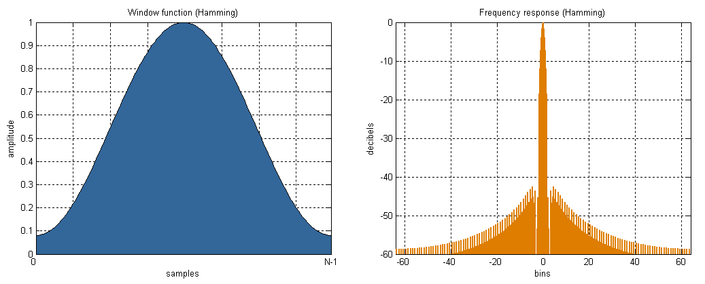

Figure 1.1 A sample Figure

Table 1.1: A sample table
Sl.No. | This is a | Sample | Table
1 | ITEM 1 | SAMPLE1 | SOMETHING
2 | ITEM2 | ANOTHER SAMPLE LINE SPREADING OVER | SOMETHING

Center Align all the Tables. Caption should appear at the top of the table. To give the caption, right click the table and choose caption with numbering as <chap No.>.<fig number>
- Scope
The scope of the project needs to be explained. Also, students must state if the project has some social or environmental impact.
CHAPTER 2 PROBLEM DEFINITION

CHAPTER 3 LITERATURE REVIEW

This Chapter details about the state of the art of the work in which students are creating the project. Students must provide the write up regarding the literature review in their own words. They should not copy and paste the contents from the paper. All the work mentioned in this section must provide the citation to the work. The same must be included in the Reference section with the square bracket followed by the reference number.[1]

CHAPTER 4 REQUIREMENTS

CHAPTER 5 DESIGN & METHODOLOGY
Design Include Architecture Diagram/ Flow chart/Workflow diagram with explanation include subheading where ever required.
Methodology refers to the overarching strategy and rationale of your project. It involves studying the methods used in your field and the theories or principles behind them, in order to develop an approach that matches your objectives.
Methods are the specific tools and procedures you use to collect and analyze data (for example, experiments, surveys, and statistical tests).
Here you clearly outline what methodology you used in your work i.e. what work you did and how you carried out the work.
It must be clearly written so that it would be easy for the reader to know how the work is done.
It is usually written in a 'passive' voice
Describe your methods of data collection
Existing data
Explain how you selected case study materials (such as texts or images) for the focus of your analysis.
What type of materials did you analyze?
How did you collect and select them?
How you prepared the data before analyzing it (e.g. checking for missing data, removing outliers, transforming variables)
It can also describe any problems that may have arisen during implementation and how you dealt with them.
Do not attempt to describe all the code in the system, and do not include large pieces of code in this section.
Complete source code should be provided separately (see Appendix B and submission guidelines).
Instead pick out and describe just the pieces of code which, for example:
• are especially critical to the operation of the system;
Can include the algorithm
CHAPTER 6 RESULTS AND DISCUSSION

Include Test Cases
Result of test case
Screen shot of the outputs
Evaluation of results in form of tables and Graphs

CHAPTER 7 CONCLUSION AND FUTURE WORK

REFERENCES
- Author1, Author2, .. AuthorN (year). "Paper/ Publication or Book Title," in Journal or conference name; <Journal issue details – volume no, page no., or Place of conference if applicable>, Year of publication.
<Please see examples below>
- G. Eason, B. Noble, and I.N. Sneddon, “On certain integrals of Lipschitz-Hankel type involving products of Bessel functions,” Phil. Trans. Roy. Soc. London, vol. A247, pp. 529-551, April 1955.
- A. Lieto, M. Bhatt, A. Oltramari, D. Vernon (2018). The role of cognitive architectures in general artificial intelligence, Cognitive Systems Research, 2018; 48:1-3. doi: https://doi.org/10.1016/j.cogsys.2017.08.003.
- J. Jin, C. Song, H. Li, K. Gai, J. Wang and W. Zhang (2018). Real-Time Bidding with Multi-Agent Reinforcement Learningin Display Advertising. CIKM '18: Proceedings of the 27th ACM International Conference

